CYB102 Project 5 (🔗 Instructions Page)

👤 Student Name: Shireen M
✉️ Student Email: sXXXXXXX@gmail.com

Reflection (Required)

🤔 Reflection Question #1: If I had to explain “what is SIEM” in 3 emojis, they would be…
(Feel free to put other comments about your experience in this unit here, too!)
🔍(Search logs), 📋(collect data), 🚨(alert on threats)

🧠Reflection Question #2: What field do you think is most important for logs to have?
The most important field is the timestamp. Without knowing exactly when something happened, you cannot reconstruct an attack timeline or correlate events across multiple sources as we saw in this lab. The timestamps were what revealed ABurke logged in at 15:18 and uploaded the malware hours later at 17:59.

📣 Shoutouts: Share appreciation for anyone who helped you out with this project or made your day a little better!
A big thank you to Google for always being there when I needed to double-check a concept, and to Claude (Anthropic's AI assistant) for helping me work through the SPL syntax step by step and making sure I actually understood what each query was doing before running it not just giving me the answers, but walking me through the logic behind them. This project would have taken a lot longer without both of these tools in my corner! 🙌

CTF Challenges (Required)

Use the answer boxes below to document any CTF challenges you completed.
- For each challenge, document both:
- The challenge answer
- The search command used to find the answer
- If you don’t complete a particular challenge, leave it blank.

Part 1 - Searching the Netflix Data (1pt each)
index=main source=Netflix
👥 Challenge 1: How many TV shows on Netflix are in the Docuseries genre?
Solution:
- It shows total of 85 Events (Search Query used: index=main host=Netflix type="TV Show" listed_in="Docuseries" )
- 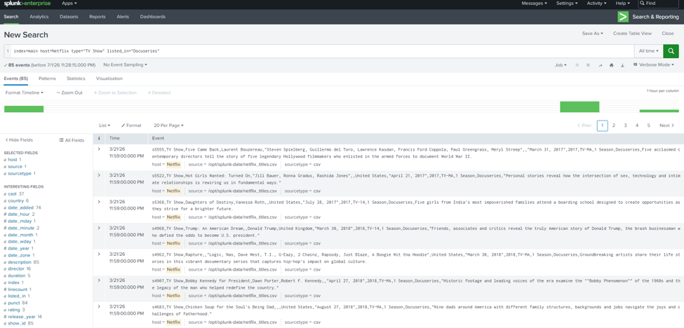

👥 Challenge 2: How many movies on Netflix have a rating of TV-PG?
Solution:
- It shows total of 540 Events (Search Query used: index=main host=Netflix type="Movie" rating="TV-PG" )
- 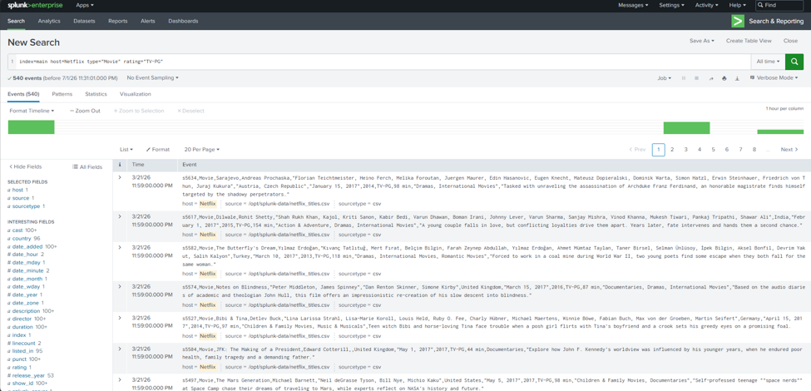

👥 Challenge 3: How many movies on Netflix were released in the year 2020?
Solution:
- It shows total of 517 Events (Search Query used: index=main host=Netflix type="Movie" release_year="2020" )
- 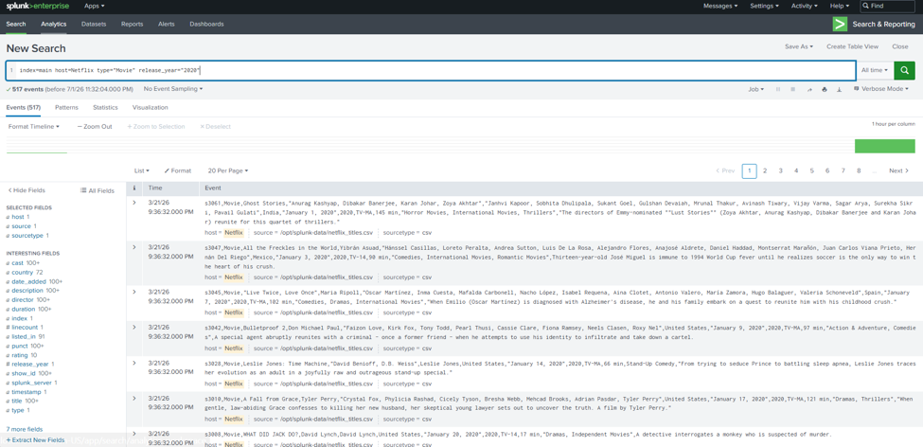

👥 Challenge 4: What is the longest duration by season on Netflix, and what is its TV rating?
Solution:
- Grey’s Anatomy : 17 seasons : TV-14 [rating]
- NCIS : 15 seasons : TV-14 [rating]
- Supernatural : 15 seasons : TV-14 [rating]
(Search Query used: index=main host=Netflix type="TV Show" | rex field=duration "(?P<seasons>\d+)" | eval seasons=tonumber(seasons) | sort -seasons | table title duration rating | head 1
AND
index=main host=Netflix title="Grey's Anatomy" | table title duration rating

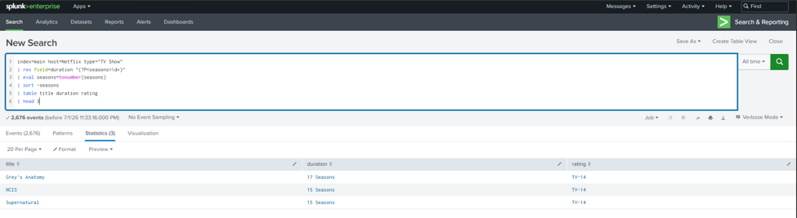

👥 Challenge 5: How many movies on Netflix are listed as rated PG-13 and listed in Action & Adventure?
Solution:
- It shows total of 23 Events (Search Query used: index=main host=Netflix type="Movie" rating="PG-13" listed_in="Action & Adventure" )
- 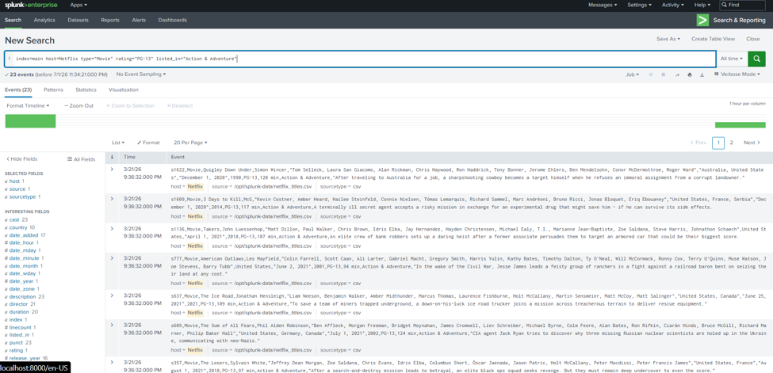

👥 Challenge 6: How many movies and TV shows on Netflix have their country of origin as Turkey?
Solution:
- Movie :76
- TV Show :29
(Search Query used: index=main host=Netflix country="Turkey" | stats count by type )
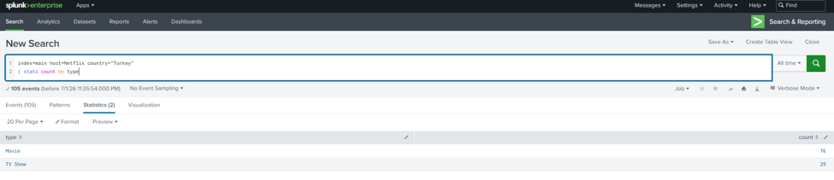

👥 Challenge 7: Which release year had the most movies rated G? (Not TV-G)
Solution:
- Release Year : 2009
- Count : 4
(Search Query used: index=main host=Netflix type="Movie" rating="G" | stats count by release_year | sort -count | head 1 )
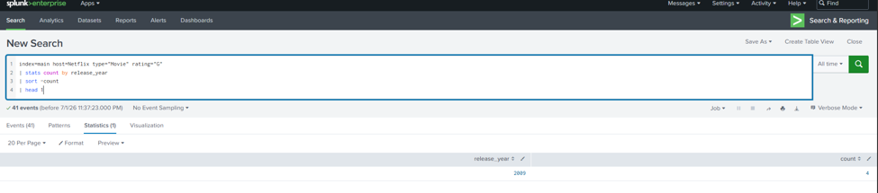

👥 Challenge 8: What two TV-Y7 rated shows were released in 2019 and were added to Netflix on November 22, 2019?
Solution:
- Trolls: The Beat Goes On!
- The Dragon Prince
(Search Query used: index=main host=Netflix rating="TV-Y7" release_year="2019" date_added="November 22, 2019" | table title)
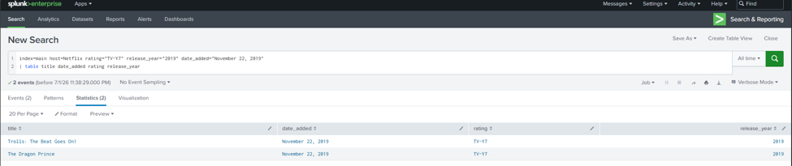

👥 Challenge 9: Which year had the most TV Shows from the United States?
Solution:
- 2020 (159 shows)
(Search Query used: index=main host=Netflix type="TV Show" country="United States" | stats count by release_year | sort -count | head 1)
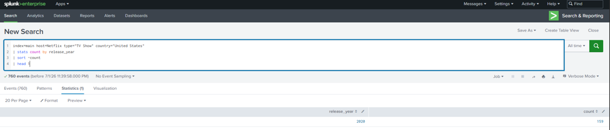

👥 Challenge 10: What is the oldest TV show by Release Year on Netflix?
Solution:
- Pioneers: First Women Filmmakers (1925)
(Search Query used: index=main host=Netflix type="TV Show" | sort release_year | table title release_year | head 1)
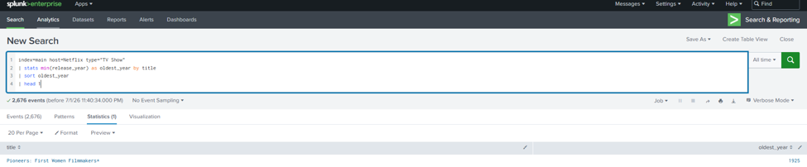

Part 2 - Investigating the Malware (2pts each)
index=pathcode

👥 Challenge 11: What was the IP address that uploaded the malware (MD5 hash: 3AADBF7E527FC1A050E1C97FEA1CBA4D)
Solution:
- 192.168.1.10
(Search Query used: index=pathcode host=uploadedhashes "File Hash"="3AADBF7E527FC1A050E1C97FEA1CBA4D" | table Timestamp IP "File Hash" Filename )

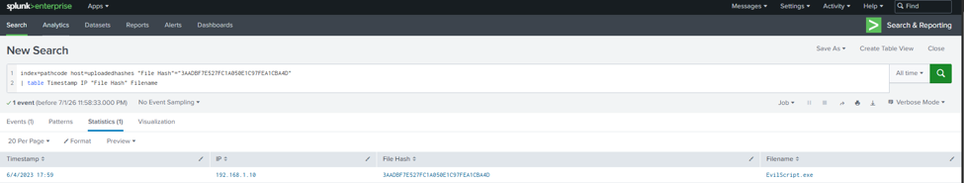

👥 Challenge 12: What usernames did that IP address try to login to the system as? Which one did they upload a file as?
Solution:
- Username: ABurke
(Search Query used: index=pathcode host=failedlogins64 IP="192.168.1.10" | table Timestamp IP Username )
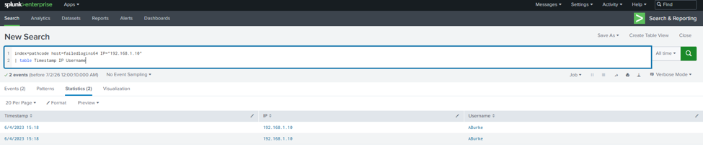

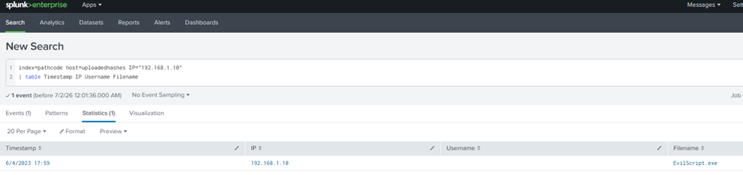

👥 Challenge 13: What was the User Agent String of the attacker when they successfully uploaded a file?
Solution:
- User Agent: Opera/75.0.3969.218
(Search Query used: index=pathcode host=uploadedhashes IP="192.168.1.10" | table Timestamp IP Username Filename "User Agent")
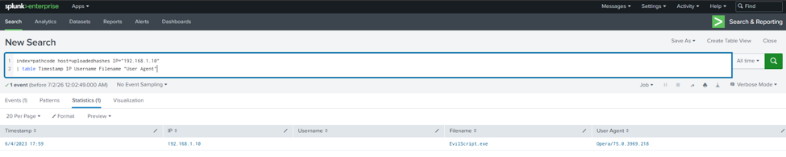

👥 Challenge 14: Did any other users also upload a file around that time? If so, who and what was their IP address?
Solution:
- Yes, another user uploaded a file around the same time the upload at 17:49 from IP 192.168.1.8 uploaded Style.css, just 10 minutes before ABurke's EvilScript.exe at 17:59.
(Search Query used: index=pathcode host=uploadedhashes | table Timestamp IP Username Filename | sort Timestamp )
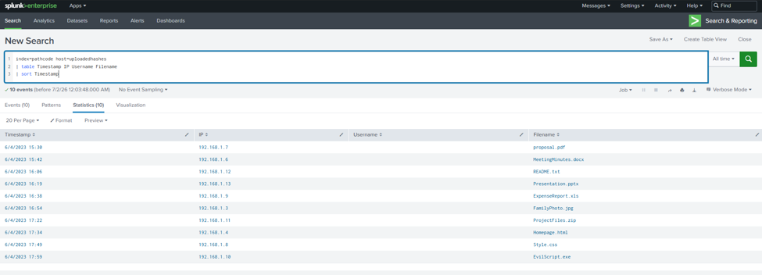

👥 Challenge 15: Looking at the uploaded hashes, what were the files called that the two users uploaded? Which one seems like it was malicious?
Solution:
- Two files uploaded around the same time: Style.css (192.168.1.8 at 17:49) and EvilScript.exe (192.168.1.10 at 17:59)
- The malicious one is clearly EvilScript.exe the name alone is a red flag, plus it matches the MD5 hash from Challenge 11
(Search Query used: index=pathcode host=uploadedhashes | table Timestamp IP Username Filename "File Hash" | sort Timestamp)
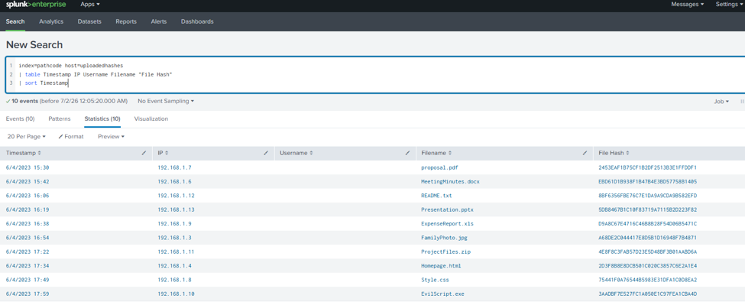

Submission Checklist
👉Check off each of the features you have completed. You will only be graded on the features you check off.

Reflection
- Reflection Question #1 answered above
- Reflection Question #2 answered above

CTF Challenge Part 1 - 1pt each |  | CTF Challenge Part 2 - 2pts each
- Challenge #1  - Challenge #2  - Challenge #3  - Challenge #4  - Challenge #5 | - Challenge #6  - Challenge #7  - Challenge #8  - Challenge #9  - Challenge #10 | - Challenge #11  - Challenge #12  - Challenge #13  - Challenge #14  - Challenge #15
(Reminder: 10pts needed for full credit)
💡Tip: You can see specific grading information, including points breakdown, by going to 🔗 the grading page on the course portal.

